| **Menoufia University** |  | **Subject: Software Engineering-1** |
| --- | --- | --- |
| **Faculty of computers and Information** | **Year: Third Year** |
| **CS, IS, and IT Departments** | **Software Engineering Project 2021-2022** |

**Software Engineering Project**

**Web Application Project**

* **Team Members:**

| **No.** | **Name** | **Dept** | **Sec** |
| --- | --- | --- | --- |
| **1** | **محمد رأفت السيد سعفان** | **CS** | **4** |
| **2** | **محمد سمير سليمان بصارة** | **CS** | **4** |
| **3** | **صابر السيد صابر عبد المقصود** | **CS** | **3** |
| **4** | **علي لبيب شفيق طاحون** | **CS** | **3** |
| **5** | **مريم إيهاب محمد عبدالرازق سرحان** | **CS** | **5** |
| **6** | **هبه السيد عبدالجواد عبداللطيف** | **CS** | **5** |
| **7** |  |  |  |

* **Project Title:**

| ***Book tickets online*** |
| --- |

# Preface

**“Book tickets online”**

**Version 1**

**14/11/2022**

* ***This documentation is oriented to:***
* Customers
* manager
* Developer
* designer
* tester

# Introduction

* **Description:**

## Problem Definition:

1. Availability to book at any time .
2. Availability to book from anywhere.
3. Shorten waiting times in the reservation queue.
4. The possibility of buying one ticket, through it he can visit any specific places, ride transportation, watch football matches, theaters and places of entertainment.

## Previous Solution:

Yes, this idea has existed before, and he provided us with it integrated

Ticketing, QR Code .

## Proposed Solution:

1. **Integrated ticketing** :- allows a person to make a journey that involves transfers within or between different transport modes with a single ticket that is valid for the complete journey, modes being buses, trains, subways, ferries, etc. The purpose of integrated ticketing is to encourage people to use public transport by simplifying switching between transport modes and by increasing the efficiency of the services.
2. **QR Code** :- It is an image consisting of digitally arranged points or lines, provided with the ticket to facilitate the process and therefore the person does not have to carry the ticket all the time, and all he has to do is highlight the camera of the dedicated device and thus keep your data and test it with ease.

* Main Functions:

1. The user can book tickets remotely.
2. The user can reserve any part of what is available with us.
3. The user can only book one ticket and enter it anywhere (the full ticket).
4. The user can cancel the reservation of the ticket after a period of time.
5. The user can easily search for an empty place

* Dependencies:

1. Internet.
2. Web browser.
3. Hardware and software.

# Glossary

*Table 1 glossary*

| **word** | **description** |
| --- | --- |
| **JavaScript** | JavaScript is a programming language commonly used in web development. It was originally developed by Netscape as a means to add dynamic and interactive elements to websites. While JavaScript is influenced by Java, the syntax is more similar to C and is based on ECMAScript, a scripting language developed by Sun Microsystems. |
| **React JS** | is an open-source JavaScript library for building user interfaces – usually for single-page and mobile applications.  A user interface in React is built around components. Each of these components is a Javascript function defined by the user. |
| **Framework** | A tool that has several components that help lay the foundation for the application you want to create, and it also provides a set of pre-written code for part of the application. |
| **CSS** | is a style sheet language used for describing the presentation of a document written in a markup language such as HTML. CSS is a cornerstone technology of the World Wide Web, alongside HTML and JavaScript |
| **HTML** | is the standard markup language for creating Web pages.It is a set of hints, commands, and tags around a given text that determines how it is organized, formatted, and described. |
| **IEEE** | Institute of Electrical and Electronic Engineers, It is a global association and organization of professionals who work for Develop, implement and maintain technology-focused products and services. |
| **DBMS** | database management system It is the software that allows a computer to store, retrieve, add, delete, and modify data, a DBMS manages all basic aspects of a database, including managing data processing, such as user authentication, as well as data entry or extraction, a DBMS defines what is called a data schema, or the structure in which data is stored, It is the software that allows a computer to store, retrieve, add, delete, and modify data, a DBMS manages all basic aspects of a database, including managing data processing, such as user authentication, as well as data entry or extraction, a DBMS defines what is called a data schema, or the structure in which data is stored. |
| **MongoDB** | is a source-available cross-platform document-oriented database program. Classified as a NoSQL database program, MongoDB uses JSON-like documents with optional schemas. MongoDB is developed by MongoDB Inc. and licensed under the Server Side Public License . |

# User Requirement Definition:

## **Functional Requirement:**

**It is required:**

1. Login page
2. Registration page
3. Home page
4. Integrated Ticketing page
5. Stadium Locations page
6. FAQ page
7. Our Stores page
8. About Tazkarti page
9. Contact us page
10. Update Information page
11. Sports page
12. Entertainment page
13. Theater page

## **Non-Functional Requirement:**

✧ I want the system to be fast and people can use the software quickly, and I want the security of the system quickly

✧ I want standardized in colors so that the background is a color and the font color is a color

✧ the software is in JavaScript language

✧ the software will be up and running for 24 hours

✧ I want the software, when the user enters the password and his name is correct, he moves to the home page, and if it is wrong, he will enter also once he enters the password and his name, and if it is wrong, he will exit the system.

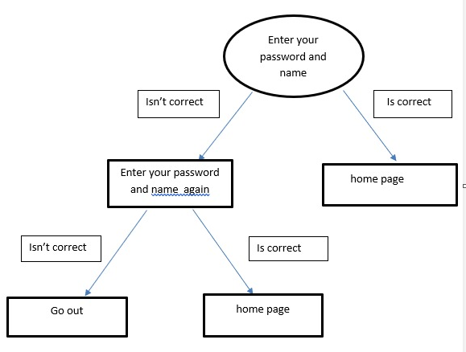

*Figure 1 system*

# System Architecture

# System Requirement Specification:

## Functional Requirement:

* **Login page**

- I want a login page.

-Sign in consists of (User Name, Password).

-username must be e-mail.

-and the password

*if letters (the maximum number of characters is 8).

*and if numbers (must be from 0-9).

-And if the user does not account, he presses the register now and creates a new account.

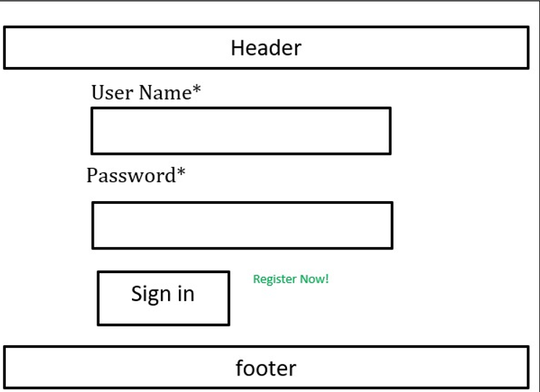

*Figure 2 login page*

* **Home page**

There are four div, set of items, login page, registration page, update information page and website logo.

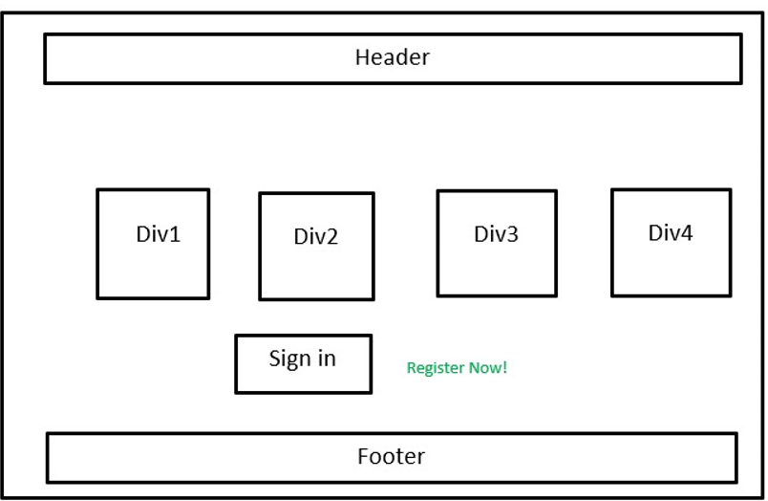

*Figure 3 home page*

* **Sports page**

- I want a sports page.

- Sport page for sports reservation tickets consists of (compo box for the team,

- Another for stadium, another for the group ,

- Another for stage, Search button to search about any match, view button.

- div for show suggested matches )

- compo box for team choose the team (must choose team)

- compo box for stadium (if you want to see matches that will be playing in that stadium)

- compo for group (for choosing the team group just available groups)

- compo box for stage (choosing the stage for match just available stages)

- search button (should choose team or stage or stadium)

- view more button (if user want to show more suggested matches press view more

- button)

- div (the user can show suggested matches)

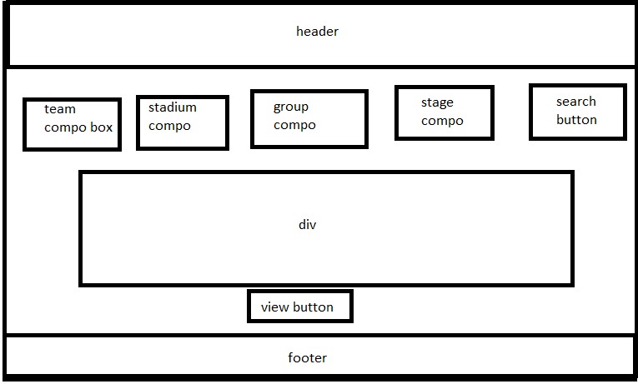

*Figure 4 sport page*

* **Entertainment page**

- I want an Entertainment page.

- Entertainment page consists of (compo box, text field,

Search button, view more button, div).

- Text Field type must be Date.

- If the user chooses type of event from compo and date of event

Press search div well show him the event available on that date.

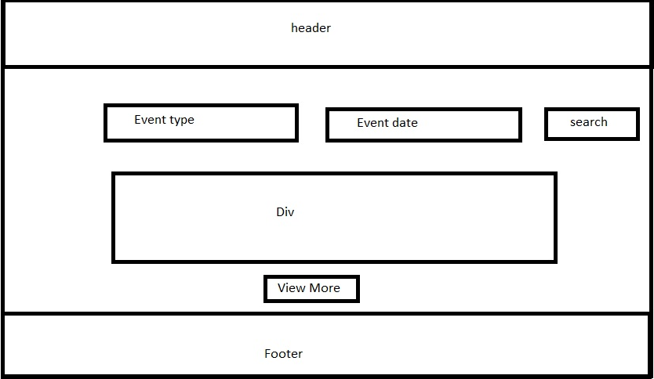

*Figure 5 Entertainment page*

* **Theater page**

Theater page service of obtaining tickets for theater and cinema is provided with ease.

At the top of the page there is a header to facilitate access to any other page on the site.

Inside the page there is a search box that allows you to search for any available tickets for theater and cinema, making it easy for you to reach the desired purpose with ease.

After the search box, there are the available shows for the theater and cinema arranged in an organized and easy way, to facilitate access to them. Each available show will contain the type of work (theater, cinema), the name of the work, the show date and the ticket price. You can get the show's ticket when you click on it, the form will appear in the presentation and get the ticket.

At the bottom of the page there is a footer to facilitate access to any other page on the site and the site's social media.

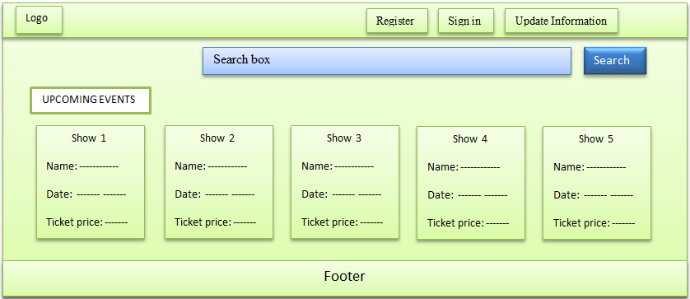

*Figure 6 Theater page*

* **Integrated Ticketing page**

At the top of the page there is a header to facilitate access to any other page on the site.

Inside the page there is a search box that allows you to search for any available integrated ticketing.

Then there are the available offers for integrated ticketing.

Integrated ticketing allows a person to make a journey that involves transfers within or between different transport modes with a single ticket that is valid for the complete journey, modes being buses, trains, subways, ferries, etc. The purpose of integrated ticketing is to encourage people to use public transport by simplifying switching between transport modes and by increasing the efficiency of the services.

At the bottom of the page there is a footer to facilitate access to any other page on the site and the site's social media.

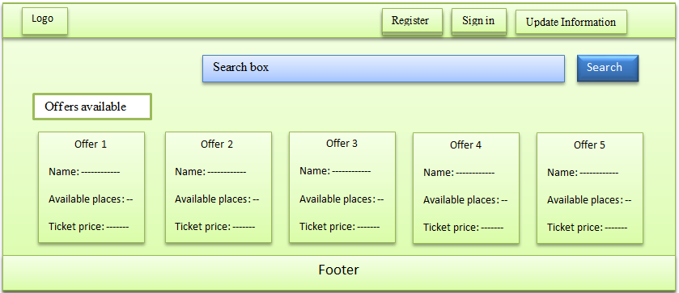

*Figure 7 Integrated Ticketing*

* **Registration page**
* At the top of the header:
* Find nave bar that contains three pages ***Register***, ***Sign in*** and ***Update Information.***
* There is also the logo on the site in the upper left.
* On this page, the site first asks the user to choose the nationality if he is an Arab or a foreigner.

For example, if he chooses the Egyptian nationality, the site will ask the user to enter contact information, which is:

* It is about the country of nationality, and it is written automatically when the user chooses the nationality.
* Then he chooses the city residing in it according to the country of nationality.
* After that He will enter the area in which he resides in this city.
* The user will enter the communication language.
* Then he will ask him the date of his birthday,
* Then he will ask for the email of the user.
* Then he will click on the checkbox to see the user, has he read and agreed to all the conditions.
* Then he will ask to verify your mobile phone number with the user:
* By entering the mobile phone number and then pressing the Send button.
* Then the site will send a message to the user It has the confirmation code.
* He will write the confirmation code in its place, then press Verify.
* Then it will ask for my ticket account type:
* entertainment account only.
* Sports and entertainment account.
* integrated tickets.
* Then press **proceed**.
* Then, in the fourth stage the site will ask the user to enter:
* the first name.
* the middle name.
* the last name.
* the blood types.
* the user's gender.
* Then it will click on **proceed**.
* Then at the last stage, there is a back button. This button will take you to the login page to enter the ticket number and the password for the ticket.
* At the bottom of the page is the footer and contains on five pages:
* Home page.
* Stadium Location page.
* Our Stores page.
* FAQ page.
* About Tazkarty page.
* Contact Us page.
* There is also the logo on the site in the upper left.

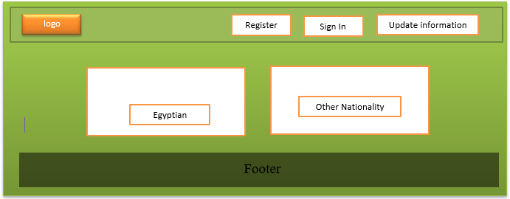

Figure 8 Register

* **Update Information page**
* At the top of the header:
* Find nave bar that contains three pages ***Register***, ***Sign in*** and ***Update Information.***
* There is also the logo on the site in the upper left.
* This page is for the user to change the data by buying a ticket, either, for example, by changing the place of viewing or changing the arrival time and so on First:
* It will ask the user to enter the order number of his ticket in which he will modify some information.
* Then it will ask the user to enter the last four digits of his national number.
* Then he will click on the “Edit Request” button. If the ticket already exists, the user will be allowed to modify it, and it will move it to the modification page, and if it is not there, it will be written. This request is not found or it has been already updated.
* Then at the last stage, there is a back button. This button will take you to the login page to enter the ticket number and the password for the ticket.
* At the bottom of the page is the footer and contains on five pages:
* Home page.
* Stadium Location page.
* Our Stores page.
* FAQ page.
* About Tazkarty page.
* Contact Us page.
* There is also the logo on the site in the upper left.

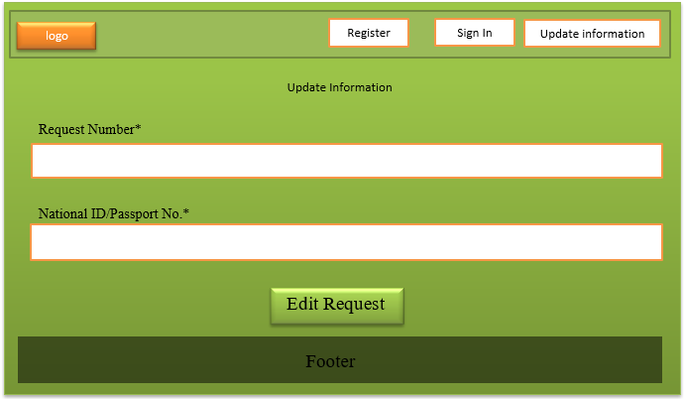

*Figure 9 Update Information*

* **FAQ (Frequently Asked Question) Page**

This Page have the most important Question about the website Services provide

[ Question and the Answer ] ,

Through these multiple questions, you can reach the answer you want to

the question that is on your mind .

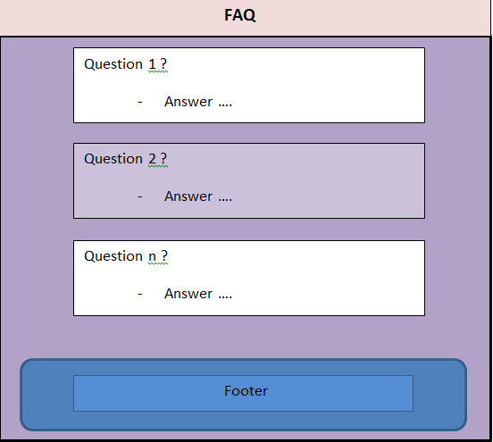

*Figure 10 FAQ*

* **About Tazkarti**

Is the creator of the first fan identification card in Egypt under the trademark

Tazkarti ID. Tazkarti is also a ticketing provider for different kinds of events

all around Egypt as well as an event organizer that plans and hosts its own events.

We offer a ticket marketplace for any and all types of events anywhere in Egypt. By using new and high-tech systems, we guarantee authorized and original tickets, accurate delivery time, as well as safety and convenience for our customers.

Providing a safe and convenient marketplace for ticket buyers in different types of events using the latest booking technologies.

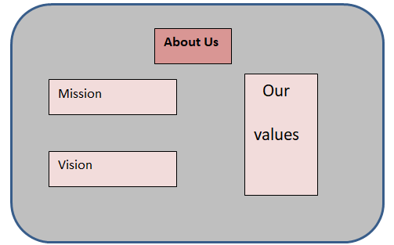

*Figure 11 about us*

* **Location of Stadiums Page**

All of our Stadium Locations , directory and how to arrive to it are exist at this page , and how many hours are these stadiums are available .

We Providing a safe and convenient marketplace for ticket buyers in different types of events using the latest booking technologies.

Through these stadiums, you can inquire about any information or obtain your own card after registering on our website

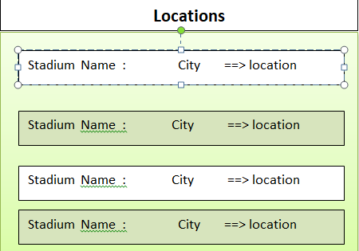

*Figure 12 Stadium location*

* **Our stores page**

All of our stores places, through which you can get your own ticket provided that

You are a holder of our car, and with this ticket, you can attend the event printed on it .

Through these stores, you can inquire about any information or get your own card after registering on our website.

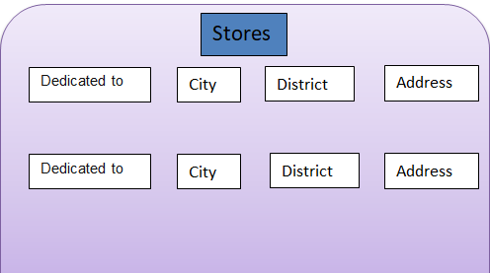

*Figure 13 Store places*

* **Contact Us page**

At the top of the header:

* Find nav bar that contains three pages: **Register**, ***Sign in*** and ***Update Information.***
* There is also the logo on the site in the upper left.
* This page is for inquiries, suggestions or complaints to make it easier for the user to complain about a problem, either or suggest something specific in booking tickets or inquire about a specific thing.
* On this page, you can contact them to inquire about something, complain or suggest a specific thing by calling them by phone number or filling out this form:
* The first box the user will choose is whether he will inquire, suggest, or complain about a particular thing.
* After that the user will enter his name.
* Then enter the email.
* After that, he will choose the country code in which he resides, and then he will enter his phone number.
* After that, the identifier will enter the ticket that is booked.
* After that, in the end there is a box in which you can write any message about a suggestion, a complaint, or an inquiry about something.
* At the end there is a send button to send a suggestion, complaint or inquiry
* After clicking, an alert appears that your request has been successfully registered.
* At the bottom of the page is the footer and contains on five pages:
* Home page.
* Stadium Location page.
* Our Stores page.
* FAQ page.
* About the Tazkarty page.
* Contact Us page.
* There is also the logo on the site in the upper left.

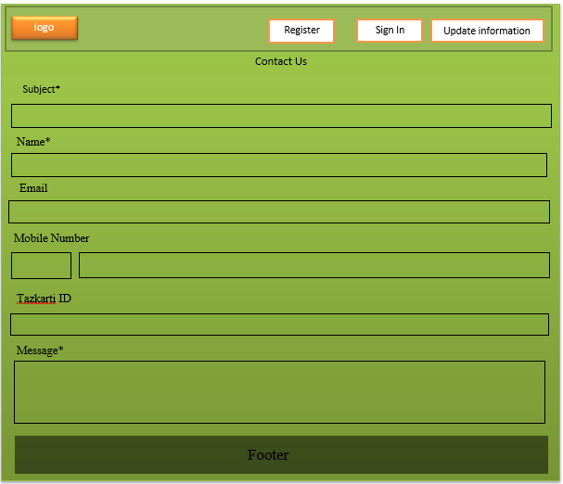

*Figure 14 Contact Us*

## **Non- Functional Requirement:**

## **1-** **Multi languages**

## The website must have three languages at least like Arabic and English because it can be accessed from all over the world.

## **2- System shall be available 24H per day and replication of data at 12pm every day**

## Everyone can access the website at any time in the day and we can take a copy of the users’ data every day at a database at 12 pm.

## **3-** **System should be efficient and fast**

## If the user clicked the sign in button it should respond in less than 3 seconds and if the user makes an order or buy something system should respond fast to finish the order and record it in the database.

## **4-** **Ease and simplicity of use**

## The system must be simple to enable users to interact with the system simply and all users should be able to use the system after a little time interacting with it and probably they will not make any errors after interacting with the system for a while.

## **5-** **The failure rate should be 1 from each 1000 users**

## At peak times there is 10 of each 1000 users who may fail to sign in to the system.

## **6-** **Data should be secured and encrypted using hashing techniques**

## Database security encompasses multiple controls, including system hardening, access, DBMS configuration, and security monitoring. These different security controls help to manage the circumventing of security protocols, protecting the underlying infrastructure that houses the database such as the network and servers, securely configuring the DBMS, and the access to the data itself. Database security measures include authentication, the process of verifying if a user’s credentials match those stored in your database, and permitting only authenticated users’ access to your data.

## **7-** **System is available for all various ages**

## Anyone who has email can create an email in the system**.**

## **8-** **System is made of html, CSS, JavaScript, bootstrap, react**

## The system should be made with html as the hypertext markup language to make the base web page and can be styled with CSS and templates of bootstrap that added to the React code and making the database with mongo dB and linking the React and node with the front-end part and with the database.

## **9-** **Mongo dB for database**

## The system must be made with mongo db.

## **10-** **System must follow standards of IEEE**

## The system should not use the camera or the microphone or the pictures without the user permission.

## **11-** **The application shall not depend on any other software**

## System can run stand-alone without the need to any external software

# System Model

* **context models :**

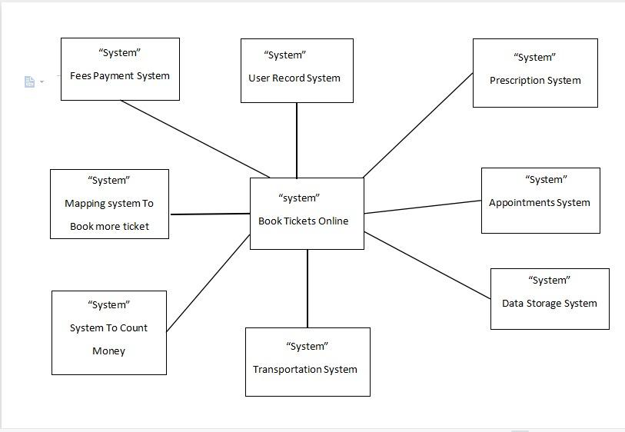

* **Use Case :**

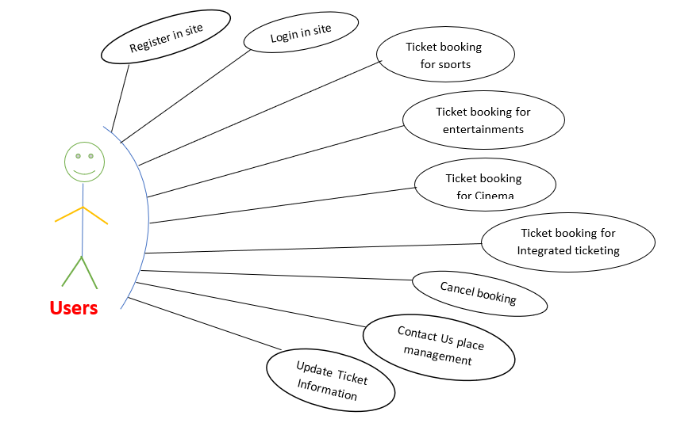

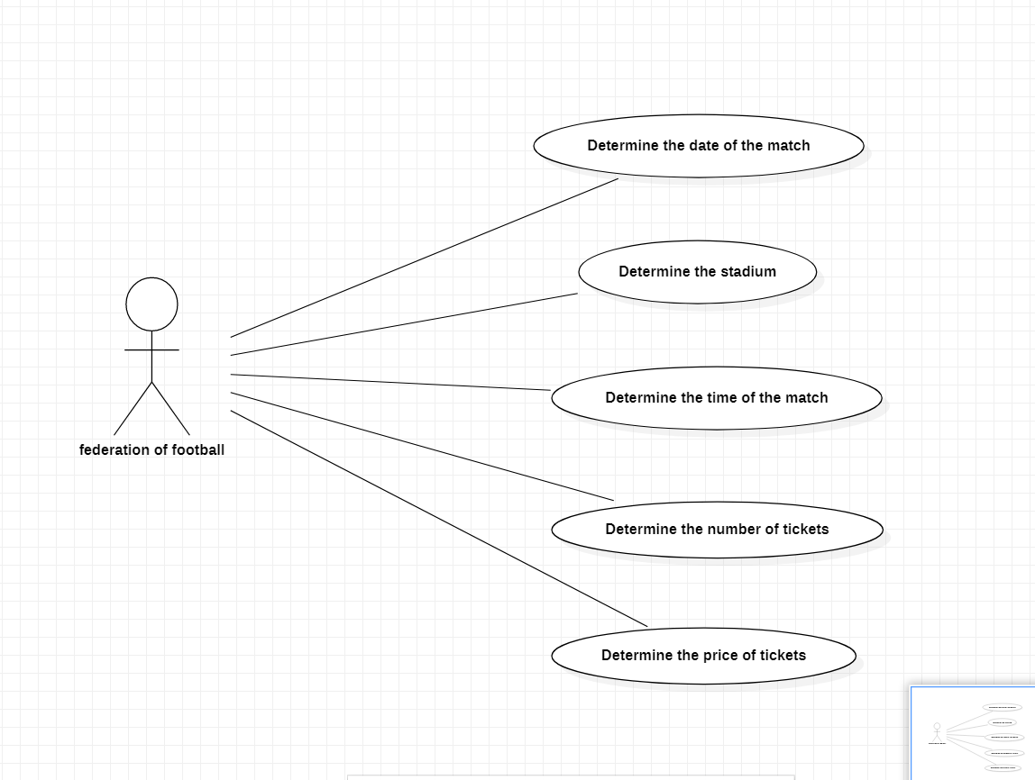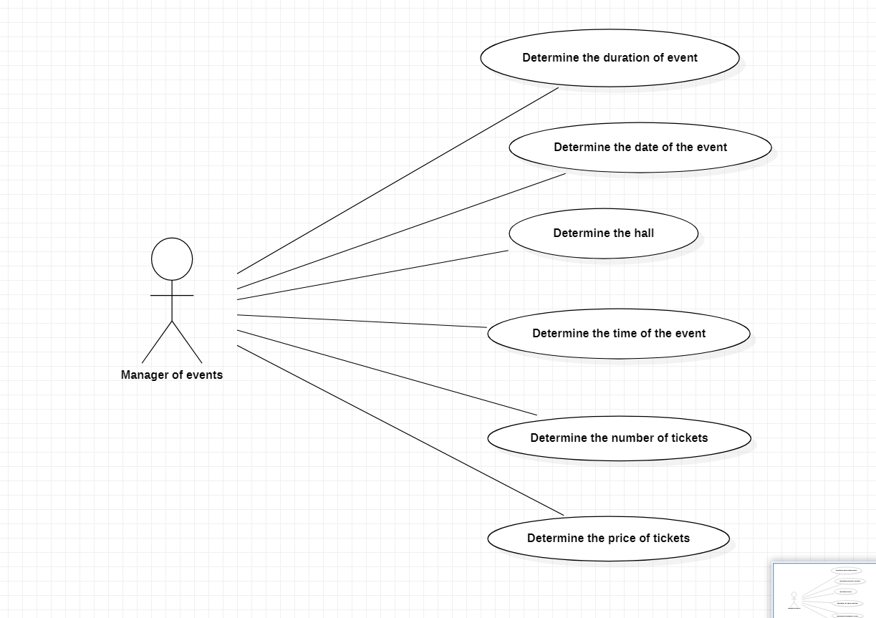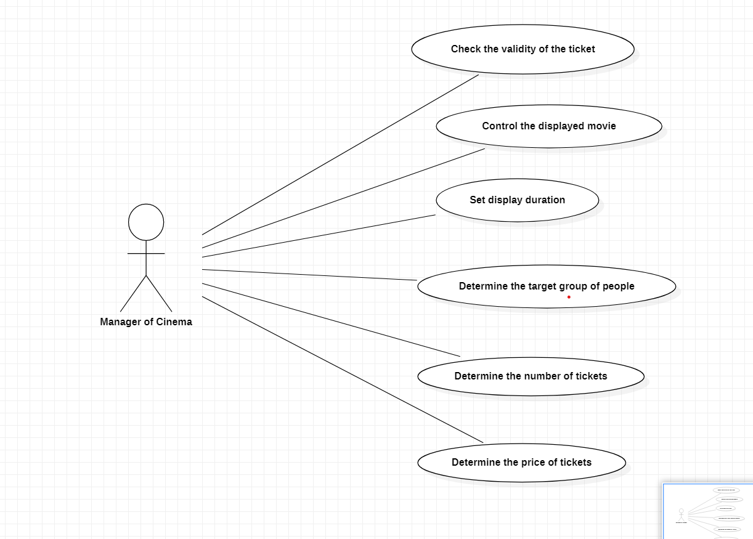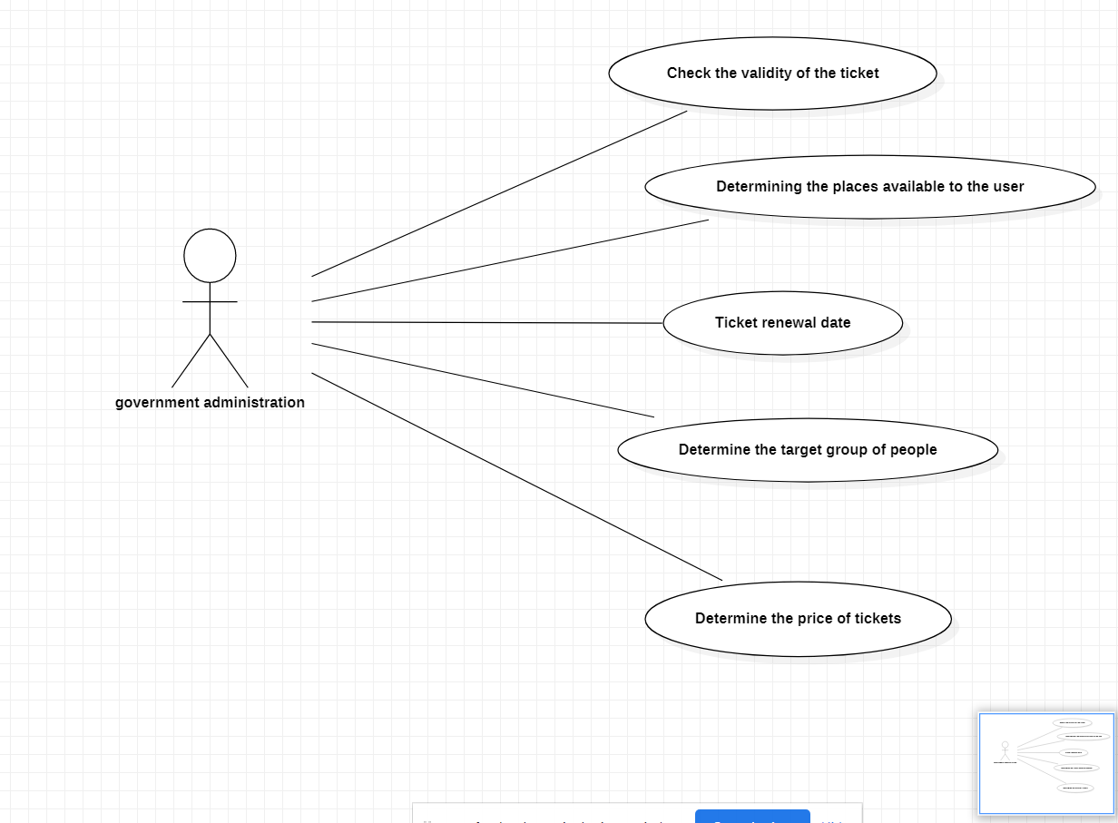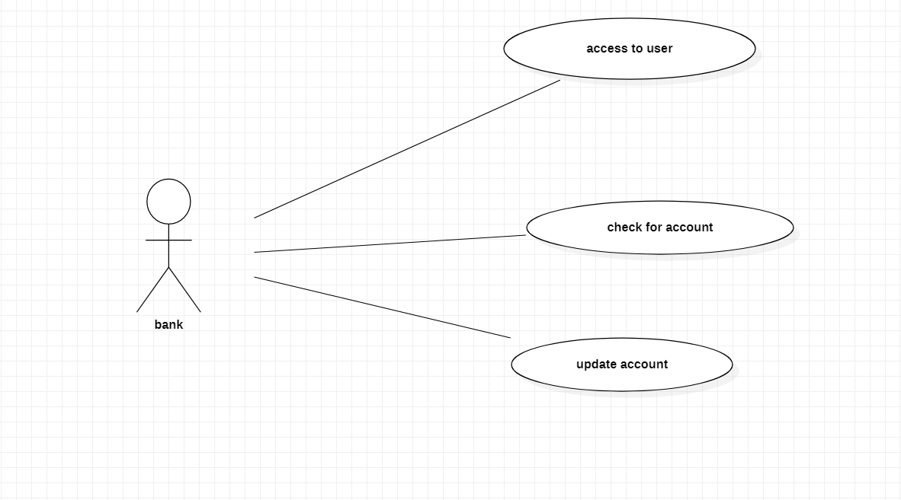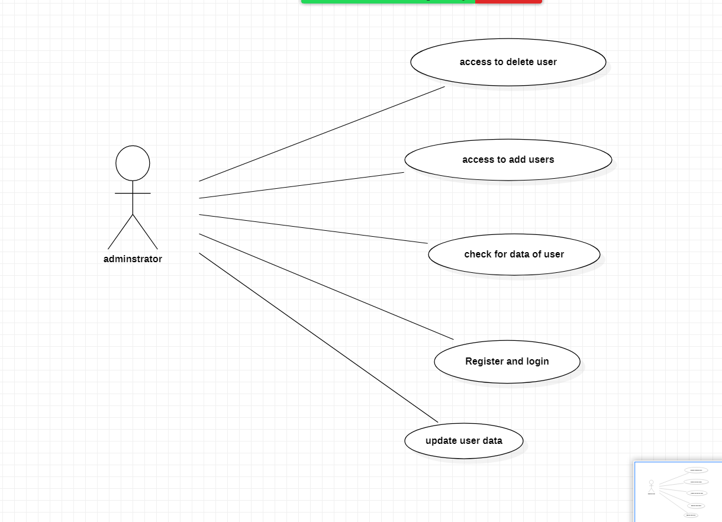

* **Sequence Diagrams :**

**Interaction for users :**

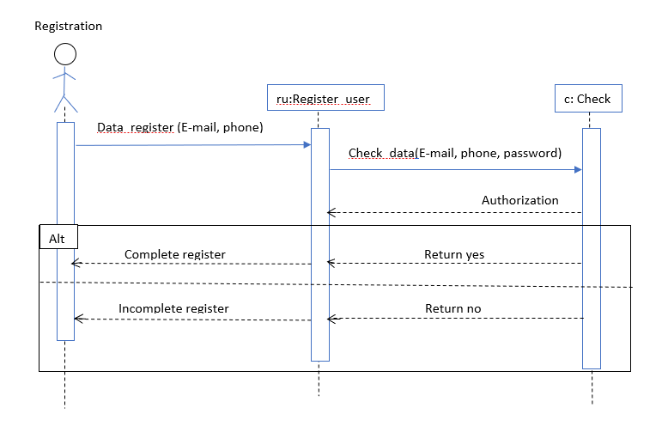

# 

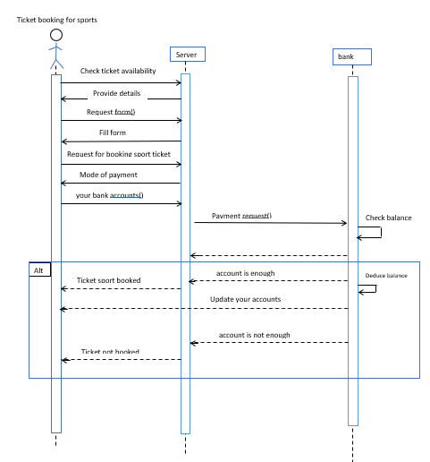

# 

# 

# 

# 

# 

# 

# 

# 

# 

# 

# 

# 

# 

# 

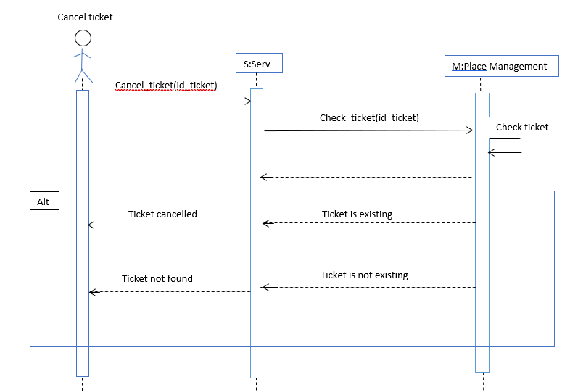

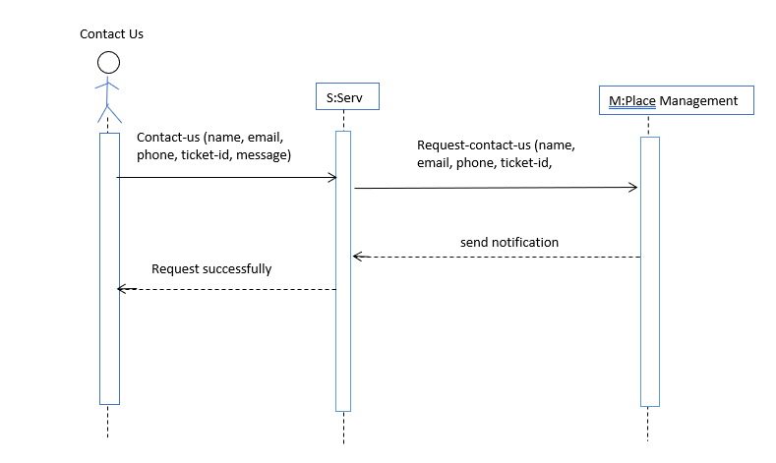

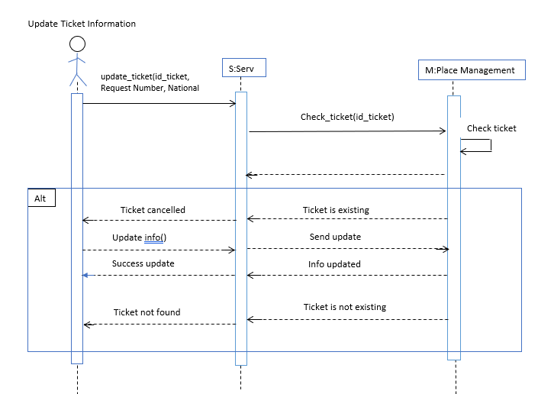

**Interaction for government administration :**

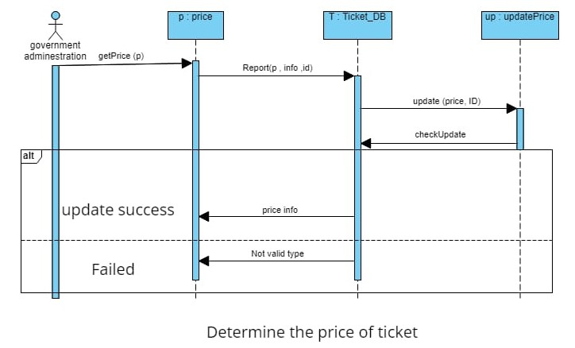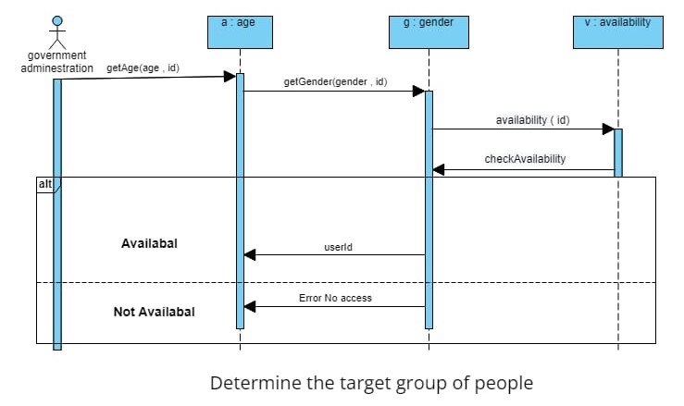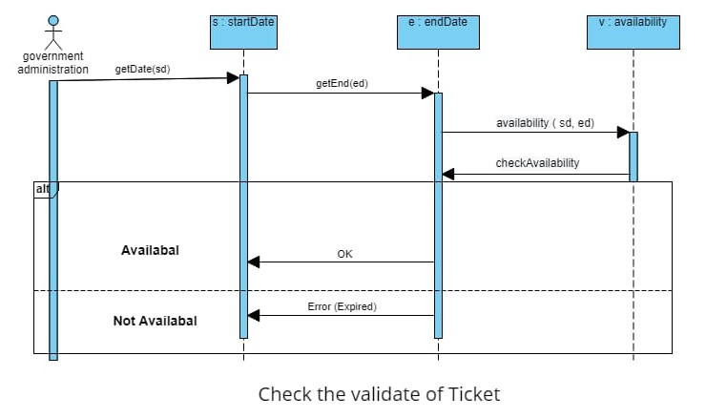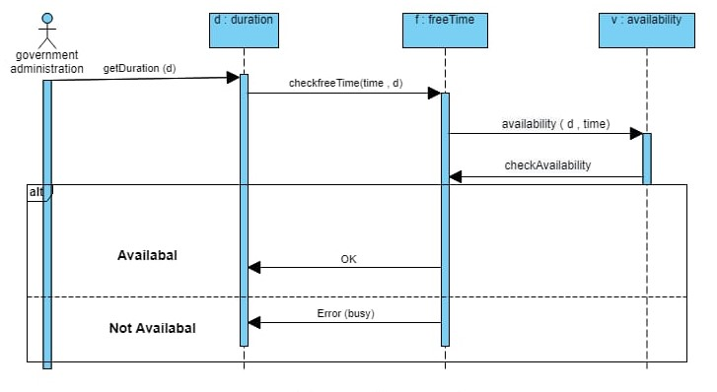

Ticket renewal date

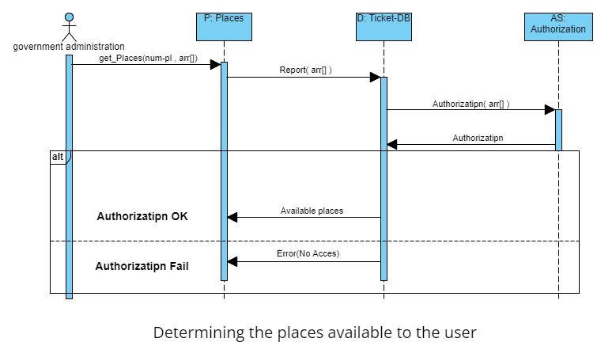

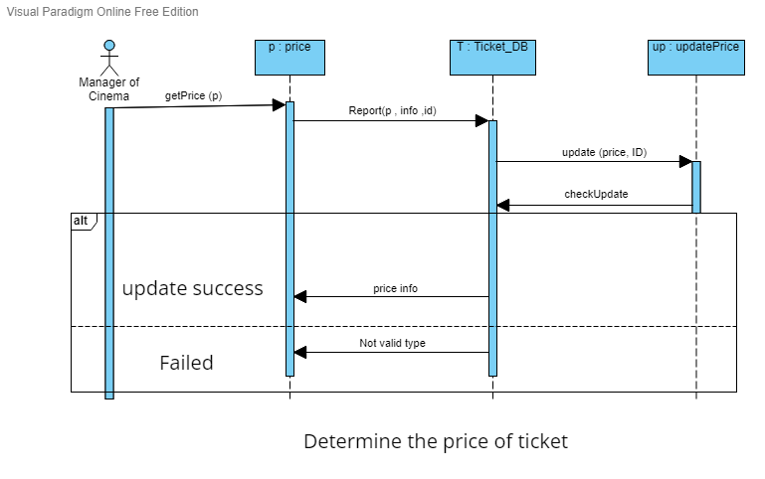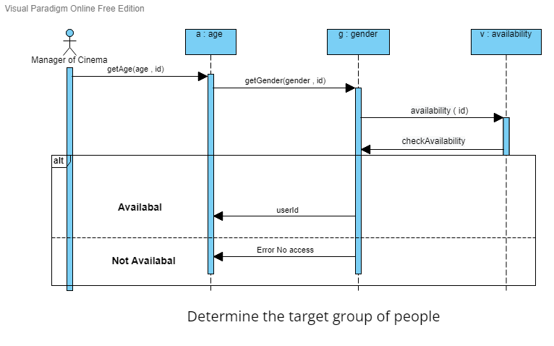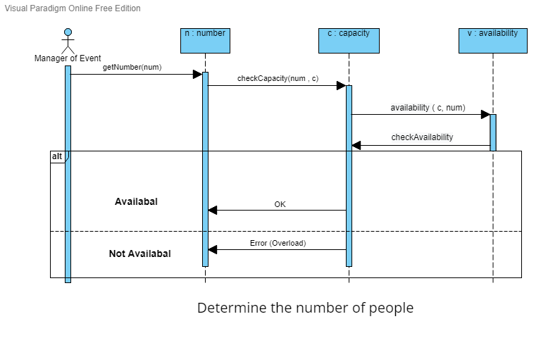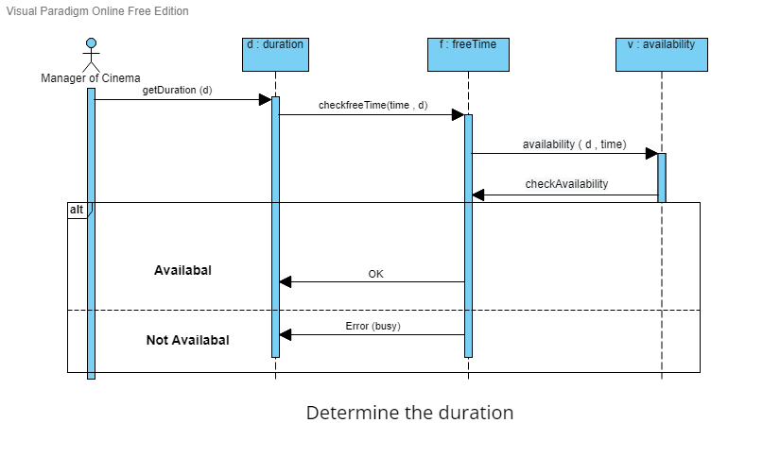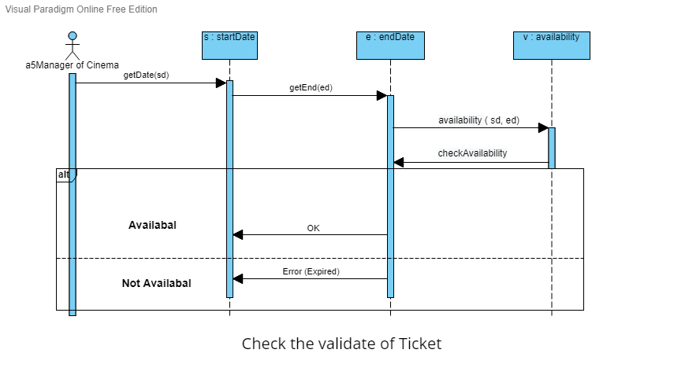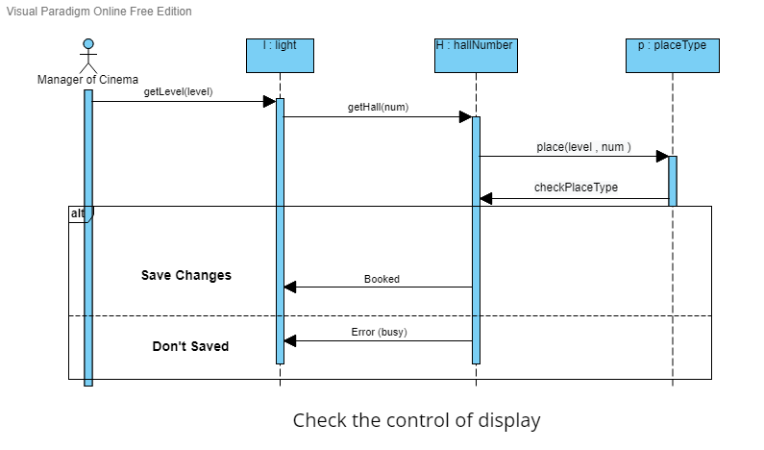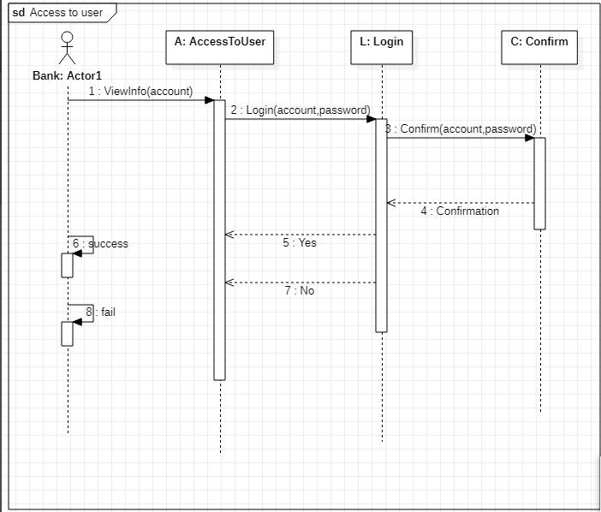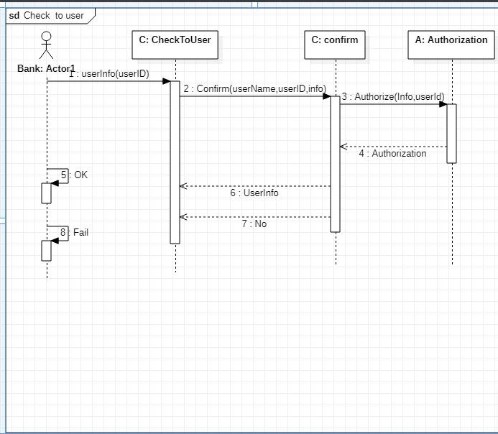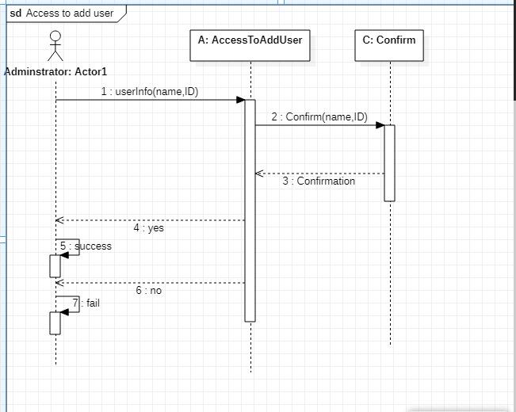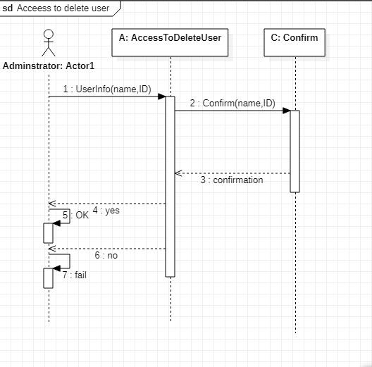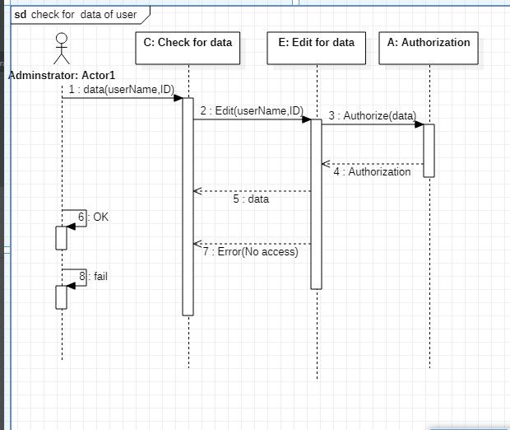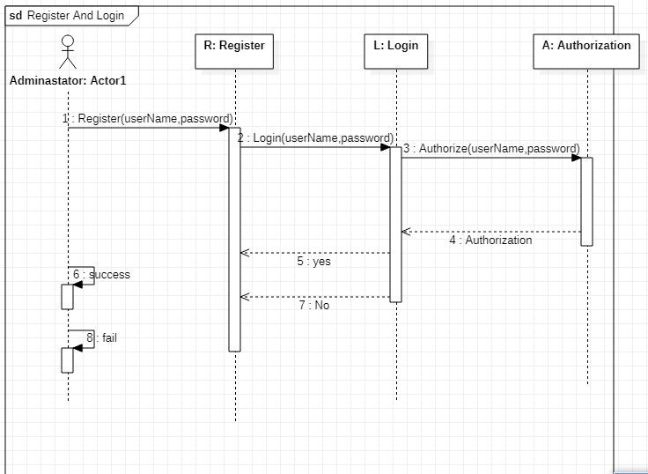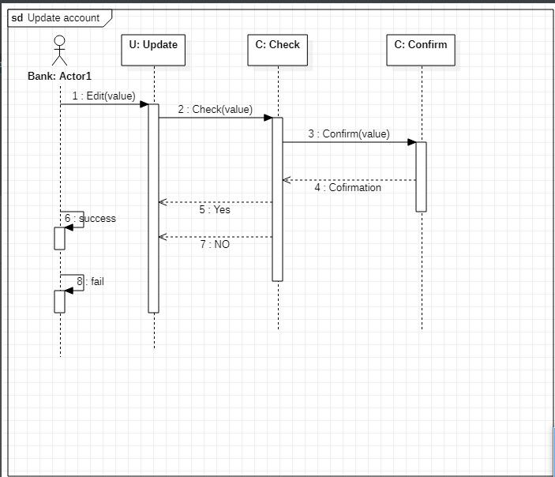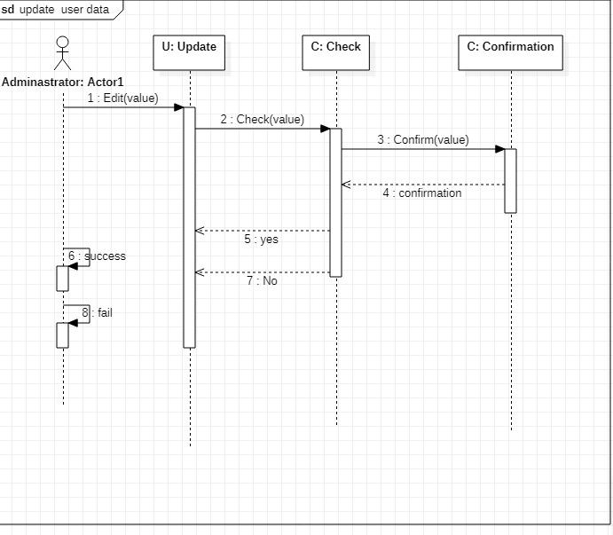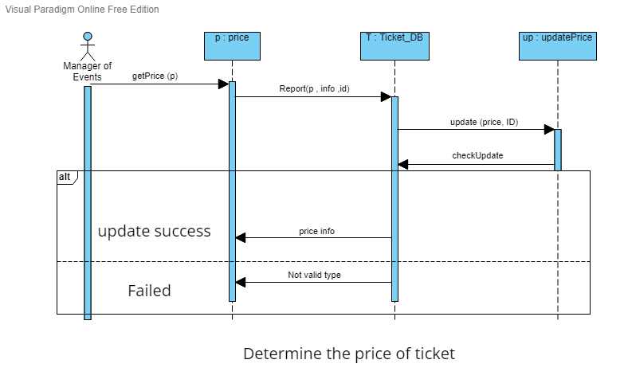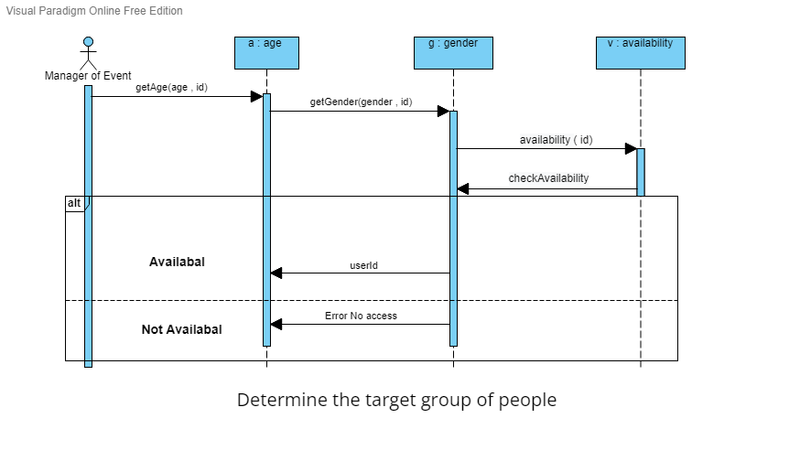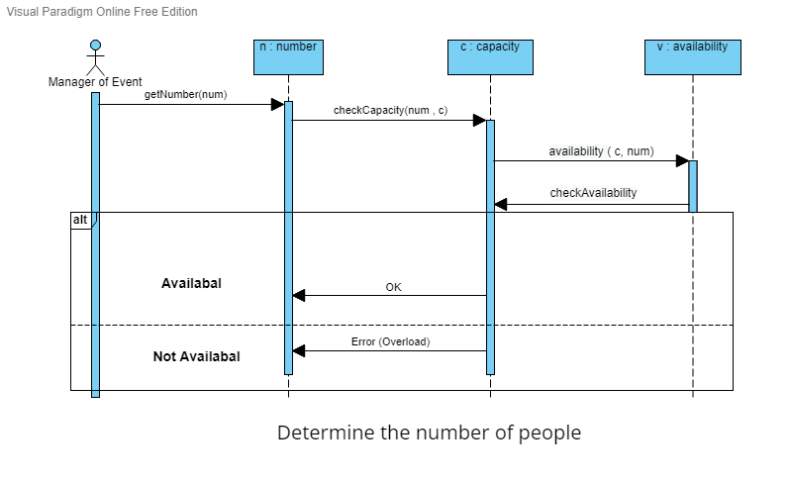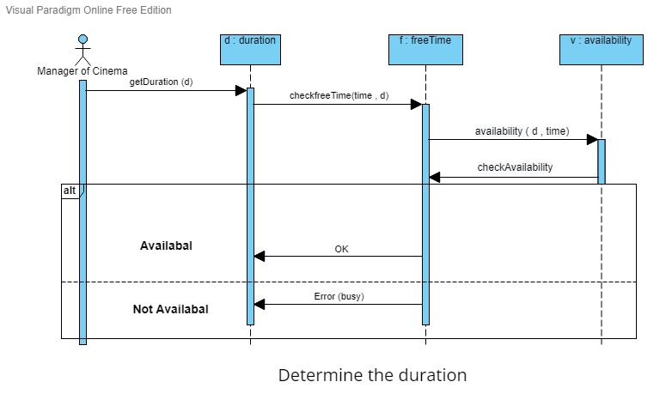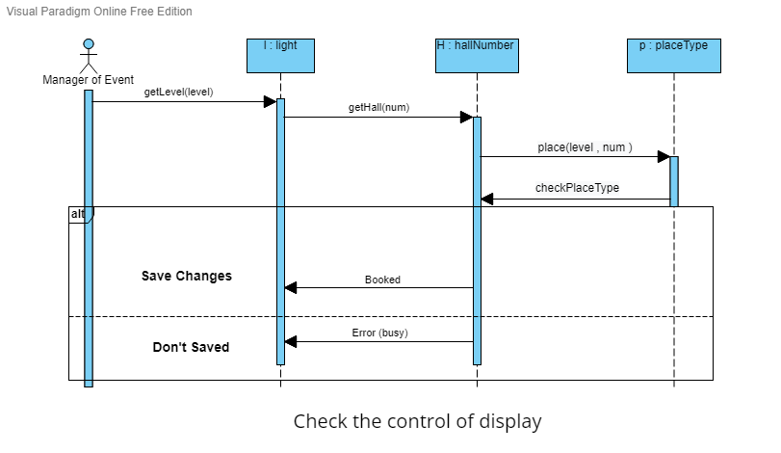

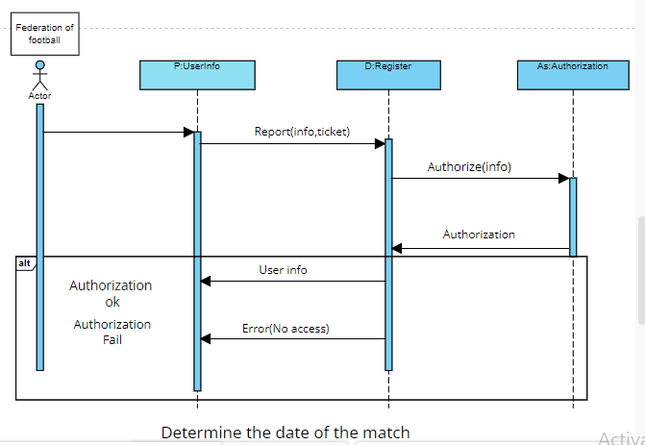

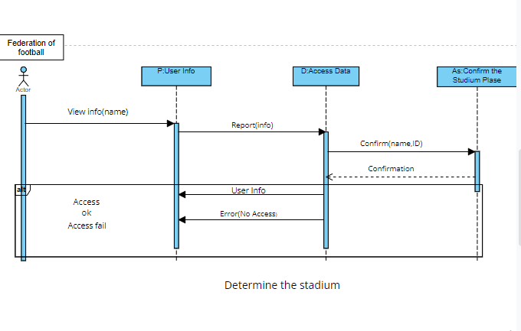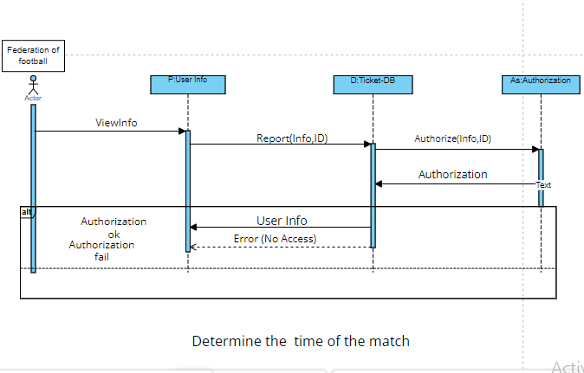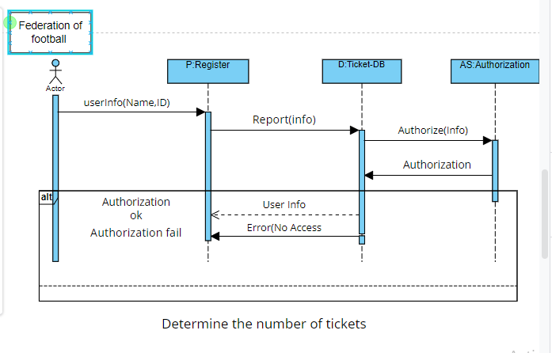

# 

Event-Driven Model

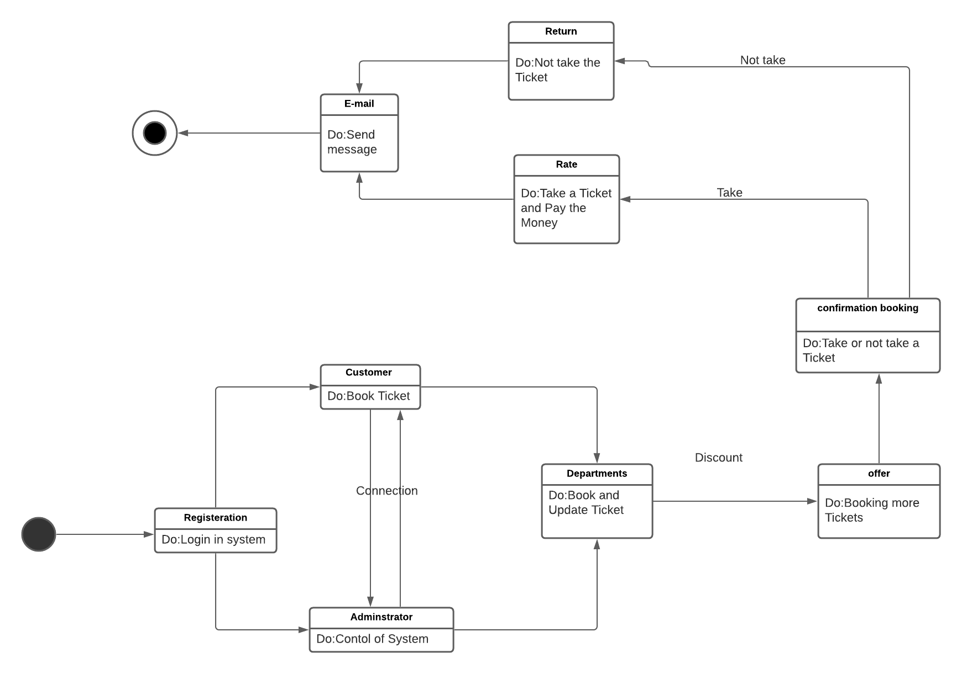

Data driven diagram

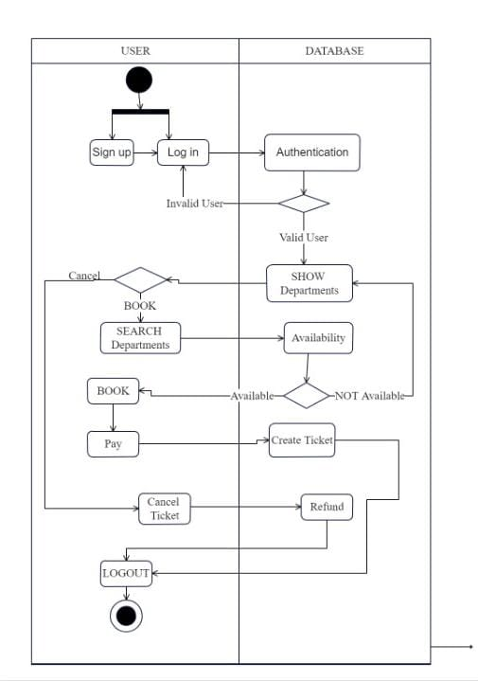

Generalization

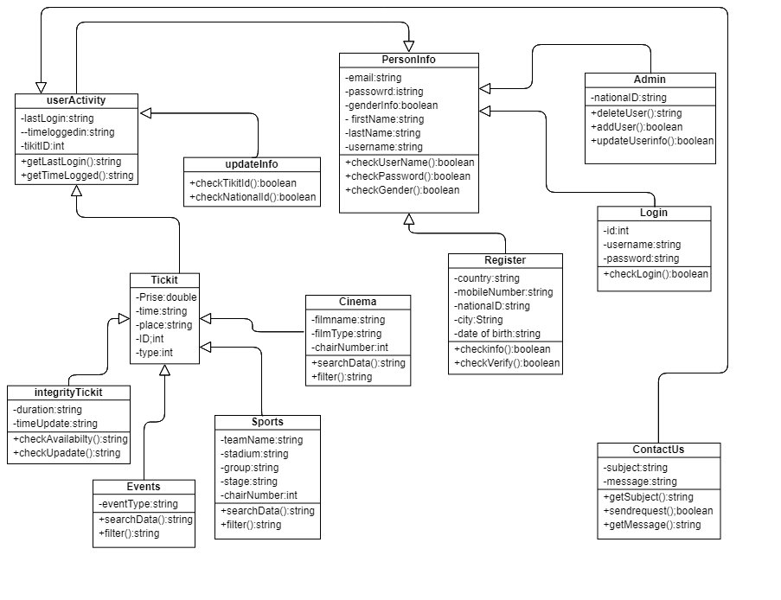

Aggregation

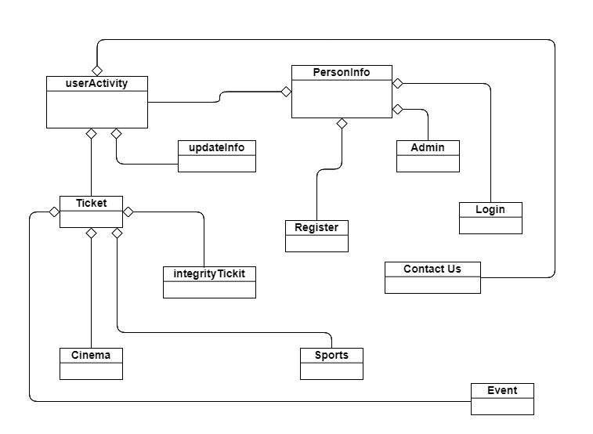

# 

# 

# System Evolution

# Appendix

## ***Hardware***:

-processor: Intel(R) Core(TM) i3-8250U CPU @ 1.60GHz 1.80 GHz

-Installed memory (RAM): 4.0 GB.

## -It is possible to open the application from the mobile.

## ***This is the least possible.***

## ***Software****:*

-System type: 32-bit Operating System,x32-based processor

-Windows, Mac and Linux.

- Mobile : ios , Android.

## ***This is the least possible.***

## ***Database***:

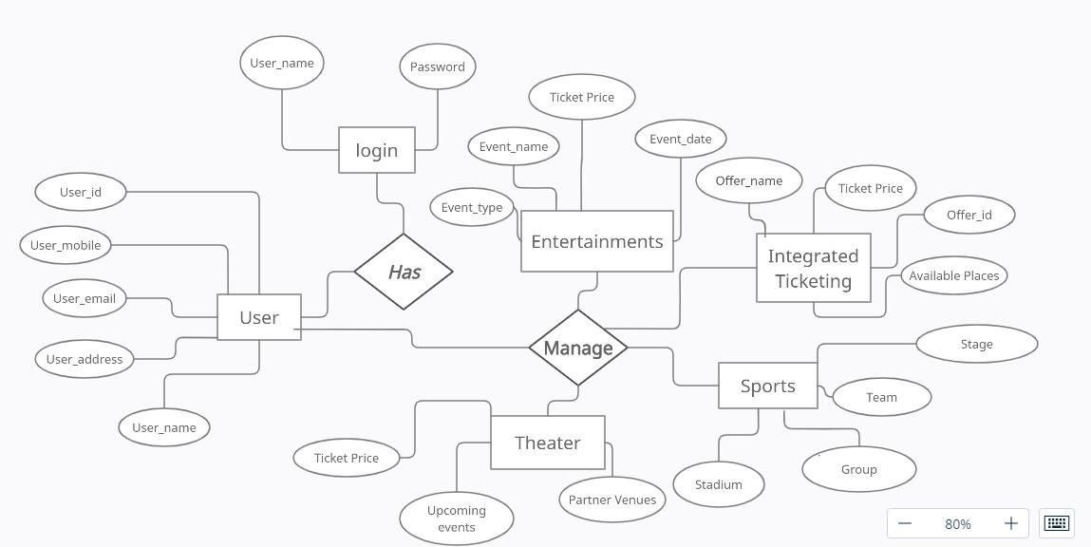

## **How to use software**:

**First** We click the login page, we will enter the(Username and Password), and we will enter the home page. We find the set of divs which is(Integrated Ticketing page-Stadium Locations page-FAQ(Frequently Asked Question) page-Our Stores page-About Tazkarty page-Contact us page-Update Information page-Sports page-Entertainment page-Theater page).

* When we click to integrated ticketing page we will find Integrated ticketing allows a person to make a journey that involves transfers within or between different transport modes with a single ticket that is valid for the complete journey,trains, subways, ferries.
* When we click to stadium locations page we will find All of our Stadium Locations , directory and how to arrive to it are exist at this page , and how many hours are these stadiums are available .Through these stadiums, you can inquire about any information or obtain your own card after registering on our website.
* When we click to the FAQ (Frequently Asked Question) page, we will find the most important Question about the website Services provide [ Question and the Answer ].
* When we click to Our Stores page,we will find Through these stores, you can inquire about any information or get your own card after registering on our website.
* When we click to About Tazkarty page,we will find

**Vision:**

Leadership in the field of sports and entertainment—being the top recognized company with both ticketing and organizing arms.

**Mission:**

Providing a safe and convenient marketplace for ticket buyers in different types of events using the latest booking technologies.

**Our Values:**

Equal opportunities in booking tickets based on a first-come first-serve basis.Original and legitimate tickets not subject to forgery.Latest technologies in booking tickets.

* When we click to contact us page ,we will find On this page, you can contact them to inquire about something, complain or suggest a specific thing by calling them by phone number or filling out this form:The first box the user will choose is whether he will inquire, suggest, or complain about a particular thing,After that the user will enter his name and Then enter the email ,After that, he will choose the country code in which he resides, and then he will enter his phone number.After that, the identifier will enter the ticket that is booked.After that, in the end there is a box in which you can write any message about a suggestion, a complaint, or an inquiry about something.At the end there is a send button to send a suggestion, complaint or inquiry.

After clicking, an alert appears that your request has been successfully registered.

* When we click to update information page,This page is for the user to change the data by buying a ticket,It will ask the user to enter the order number of his ticket in which he will modify some information,Then it will ask the user to enter the last four digits of his national number,Then he will click on the “Edit Request” button. If the ticket already exists, the user will be allowed to modify it, and it will move it to the modification page, and if it is not there, it will be written. This request is not found or it has been already updated.
* When we click to Sports page, Sport page for sports reservation tickets consists of (compo box for the team, we will find search button (should choose team or stage or stadium) view more button (if user want to show more suggested matches press view more button) ,div (the user can show suggested matches).
* When we click to the entertainment page, We will find a combo box, text field,Search button, view more button, div.Text Field type must be Date.
* When we click to Theater page,we will find search box that allows you to search for any available tickets for theater and cinema, making it easy for you to reach the desired purpose with ease,After the search box, there are the available shows for the theater and cinema arranged in an organized and easy way, to facilitate access to them. Each available show will contain the type of work (theater, cinema), the name of the work, the show date and the ticket price. You can get the show's ticket when you click on it, the form will appear in the presentation and get the ticket.

# Index:

## Table of content

**Contents:**

Preface *:*2

Introduction 3

o Problem Definition: 3

o Previous Solution: 3

o Proposed Solution: 3

Glossary 4

User Requirement Definition: 5

❖ **Functional Requirement:** 5

❖ **Non-Functional Requirement:** 5

System Architecture 7

System Requirement Specification: 8

❖ Functional Requirement: 8

❖ Non- Functional Requirement: 25

System Model 25

* context models
* Interaction Perspective
* Use Case
* sequence Diagrams

26

System Evolution 27

Appendix 28

* Hardware 28
* Software 28
* Database 28
* How to use software 28

Index: 29

Table of content 29

Table of figures 30

Table of tables 31

## Table of figures

Figure 1 system 6

Figure 2 login page 8

Figure 3 home page 9

Figure 4 sport page 10

Figure 5 Entertainment page 11

Figure 6 Theater page 12

Figure 7 Integrated Ticketing 13

Figure 8 Register 17

Figure 9 Update Information 18

Figure 10 Contact Us 21

## Table of tables

Table 1 glossary 4